**One-dimensional Ising model**

A thesis submitted to the National Institute of Technology Patna

in partial fulfilment of the requirements for the award of the degree of

INTEGRATED MASTER OF SCIENCE

In

PHYSICS

(Specialization in Computational Physics)

**By**

**Shashank Sinha**

**Roll No : 1810002**

Under the supervision of

**Dr. Anurag Sahay**



DEPARTMENT OF PHYSICS

NATIONAL INSTITUTE OF TECHNOLOGY PATNA

November 2022

© 2022 Shashank Sinha, All rights reserved.

**NATIONAL INSTITUTE OF TECHNOLOGY PATNA**

**(An Institute under Ministry of HRD, Govt. of India)**

**ASHOK RAJPATH PATNA - 800005 (BIHAR)**

**CERTIFICATE OF APPROVAL**

This is to certify that the thesis entitled **‘One-dimensional Ising model**’ submitted by **Shashank Sinha**, Roll No. **1810002**, Enrolment No. **180222** to the National Institute of Technology, Patna, is a record of bona-fide student and is worthy of consideration for the award of degree of Integrated Masters of Science in Physics of the institute.

Dr. Anurag Sahay

(Project Supervisor)

____________________

**ACKNOWLEDGEMENT**

I would like to express my gratitude to my project guide **Dr. Anurag Sahay** for his guidance and supervision in carrying out this project. Without his constant encouragement and motivation, completing this report would have been impossible. I would also like to thank **Dr. D.K. Mahto, HOD, Dept. of Physics, NIT Patna** for his cooperation and also for providing the necessary facilities to complete this report. I am also thankful to the entire Dept. of Physics, NIT Patna for providing the environment for us students to perform our best. Finally, I would also like to thank my **Parents and Friends** who supported me and helped me a lot in finalizing and completing this report within the limited period.

Shashank Sinha

**Contents**

1 Abstract……………………………………………………………………………….. 5

2 Introduction…………………………………………………………………………. 6

2.1 Ising model in different dimensions………………………………. 8

2.2 Hamiltonian of Ising model……………………………………………. 9

3 Transfer matrix method……………………………………………………….. 10

3.1 Partition function of transfer matrix……………………………… 11

3.2 Partition function in terms of eigenvalues…………………….. 13

3.3 Free energy…………….…………………………………………………….. 13

3.4 Correlation function and correlation length………………….. 15

4 References…………………………………………………………………………... 20

**Abstract**

In the process of study of statistical mechanics, Models are the main instrument that allow to “translate” the physical configuration of a system in mathematical language, and hence in figuring out the thermodynamical properties of system. In this process, the system can be thoroughly studied and its behaviour can be predicted. The role of models in statistical mechanics, and more in general the role of models in whole scientific method, is of course a very intriguing and philosophically demanding one.

The model discussed in statistical mechanics here is Ising model. In this model, the main aim was to study the one-dimensional model. The one-dimensional Ising model consists of a chain of N spins, each spin interacting only with its two nearest neighbours. There are many methods to solve the Ising model. The methods discussed is Transfer matrix method, also calculating the thermodynamical properties of system from the transfer matrix like free energy, correlation function and correlation length.

**The Ising Model (Introduction)**

In 1925, Ernst Ising in his PhD thesis proposed the Ising model, (in its one-dimensional version). At that time, it was proposed as a tool to describe the thermodynamic properties of magnetic systems, from the microscopic point of view.

In the case where system does not exhibit any phase transition, for T > 0, Ising found and incorrectly concluded that the whole model was not useful to describe such systems.

However, this model has been later studied again in different configurations. And from the studies, many important properties have been discovered. Historically, Ising model has been one of the most heavily studied model in the field of statistical mechanics. This model was also often used as a testing ground, when new theories or methods are developed.

Another extremely important characteristic of the Ising model, is that it does not only apply to magnetic systems, but can also be applied to many other systems, which can be shown to be equivalent to an appropriately defined Ising model.

The d-dimensional Ising model is defined as follows - consider a d-dimensional lattice with N sites, each labelled by the index i = 1 , … , N.

In general case of d-dimentions, the lattice is supposed to be hypercubic, but this is not necessary. In 2-dimensions, we can consider “triangular” or “honeycomb” lattices, while in 3-dimensions, we can have “body-centered” or “face-centered” cubic lattices.

What distinguishes one lattice from another is its coordination number z. The coordination number (z) is defined as the number of the nearest neighbours of a site.

In the case of hypercubic lattices, it can be easily seen that

z = 2d

, where d is the dimensionality of the system.

The discrete variables Si are the degrees of freedom of the model, which are defined on each site that can only assume the values +1 and -1 . As N are the total number of sites, and each site has 2 possible configurations. Therefore, the number of the possible configurations of the system is 2N .

The lattice in the Ising model actually represents the atomic lattice of a metal and the variables Si are the spins of the atoms, or maybe their component along the vertical axis.

Therefore,

Si = +1 🡪 corresponds to a spin pointing upwards,

Si = -1 🡪 corresponds to a spin pointing downwards.

The study of this model determines that, whether all these spins can align so that the system can have a spontaneous net magnetization, and also how this happens.

However, as the Ising model can also be used to describe completely different systems, this interpretation is not the only possible interpretation. Even though other representations might have many similarities, since this model is always been associated to magnets, so in the following contexts, terminology proper only to magnetic systems are used mostly.

The visual representation of Ising model for various dimension is as follows :-

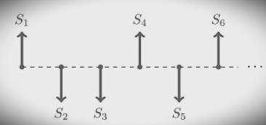

*Fig : Ising model in 1-dimension*

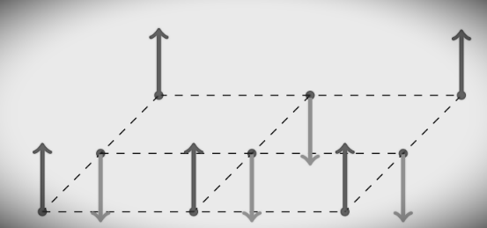

*Fig : Ising model in 2-dimensions*

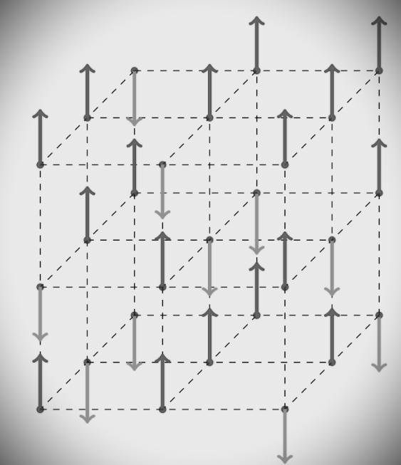

*Fig : Ising model in 3-dimensions*

The usefulness of the Ising model goes much further than what can now be imagined, as this model can also be used to describe systems different from magnetic ones. Lattice theories are in fact widely used in many areas of physics. For example - apart from general applications of Ising model in solid state physics, it is also used in formulating quantum relativistic theories in terms of lattices. We therefore see that this also models with dimensionality greater than 3, which can be actually useful.

For making this model look interesting, the degrees of freedom Si must not be independent. We therefore assume that the spins interact with each other with exchange interactions that couple in general an arbitrary number of spins, and also with an external field H that can change from site to site. Therefore, the most general form of the Hamiltonian of Ising model for a given spin configuration is :

First term, having expression like Si shows the dependence upon external magnetic field (Hi). Second term, having expression like S­iSj shows the correlation between neighbouring spins in 1-dimentional system. Similarly, third term having expression like SiSjSk shows the correlation between spins in 2-dimentional system, as one of the spin is reference spin, and other two are it’s neighbours along the 2-dimentions. Similarly, further terms keep on adding till the correlation term due to d-dimentional system. (where d = 1, 2, .. N)

The first two negative signs symbolise the alignment of two adjacent magnetic moments, in general. So for the stability of system, considering energetic convenience, it is better to have as many aligned spins as possible.

There are many methods to find the solution of Ising model Hamiltonian, some of them are :-

1. Transfer Matrix method
2. Mean field theory

**Transfer Matrix method**

The Transfer Matrix method allows us to extend our considerations also when h 0 (having some external magnetic field) and to compute other interesting properties is the so called transfer matrix method, which basically consists in defining an appropriate matrix related to the model such that all the thermodynamic properties of the system can be extracted from the eigenvalues of this matrix. We are going to see this method applied to the one-dimensional Ising model, but its validity is completely general; we will stress every time if we are stating general properties of the transfer matrix method or restricting to particular cases.

For one-dimensional Ising model, the Hamiltonian with periodic boundary conditions when an external field is present is such that :

Where, : is called reduced Hamiltonian.

Now, the Partition function for this is :-

For a 1-dimensional system of N-spins, Partition function is :-

As, we can write :

So, we can define the transfer matrix T as :

Now, we can write the partition function (ZN) as product of the elements of transfer matrix (T) :

Assuming Si to be orthonormal, i.e. :

, and |

Now, since the vectors | are orthonormal, we have :

Where, I = Identity matrix

Now, becomes :

Now, representing transfer matrix (T) in explicit way :

Substituting values in above equation of :-

T =

Partition function can also be stated as :

This is the main purpose of transfer matrix method, to express the partition function of a system, as the trace of the Nth power of an appropriately defined matrix.

For computing trace of ­, diagonalization of transfer matrix is required. We have :

Where, P -> invertible matrix (columns are eigenvectors of T)

So,

Now, expression of partition function becomes,

From the cyclic property of trace, it becomes,

For the case of 1-dimensional Ising model, will be a 2x2 matrix, so will have only 2-eigenvalues. Let, the eigenvalues be and , and assuming . Now, partition function’s expression becomes :

This was for 2-dimensional case, but for general case where T is a (n+2)x(n+2) matrix, then it will have (n+2) eigenvalues. Assuming that they are , , , … , . Also assuming their following relation :

For, this case the partition function expression becomes :

From this we conclude that, if we also consider the interaction of spins in longer ranges, then the dimension of transfer matrix will also increase accordingly. Or, this will also be the case, if we allow spin variables to have more possible values. The computation of eigenvalues will also become difficult as the size of transfer matrix keeps increasing.

From transfer matrix, we can compute some properties of the generic system, like Free energy, correlation function, correlation length, etc.

**Free energy**

Considering general system of N spins with eigenvalues , the partition function for such system will be :

Now, the mathematical expression of free energy for a system is,

Now, as we know is the greatest eigenvalue, So, for N ->

All the values, , , … tends to zero.

For such constraints over N, partition function becomes :

, where -> largest eigenvalue of the system

So, we can say that for an infinite spin-system, the partition function depends only on the largest eigenvalue of the transfer matrix. If we somehow calculate it, we can get the expression of partition function, and hence also the expression of free enery and other properties of the system, i.e. entire thermodynamics of the system.

Now, the free energy expression becomes :

, for condition N ->

As, only is involved in the expression of free energy, this has an important consequence on the probability of occurring of phase transition. As Perrron-Frobenius theorem states that :

If A is an nxn square matrix (with n as finite value), also > 0, i,j . Then, the eigenvalue with largest magnitude is:

1. real and positive
2. non-degenerate
3. an analytic function of the elements

For a one-dimensional Ising model with nearest neighbour interaction as the only considered interaction (i.e. a simple system), these properties are satisfied, and we get :

1. , so that free energy(f) is well defined.
2. is analytic, and therefore so is free energy(f).

So, from last point of one-dimensional Ising model summarisation, we can conclude that, there will be no phase transition taking place for . If , some elements of T diverge, and then the Perron-Frobenius theorem can’t be applied.

**Correlation function and Correlation length**

To compute the correlation function of the system, the transfer matrix method also comes in use. Similarly, it is used to compute the correlation length of a system. For doing so, first we have to get the two-point correlation function of the system.

For two spins which are separated by R sites of distance, the connected correlation function is stated as :

Here, the periodic boundary condition is considered for the first and the R-th spins. So, this choice is equivalent to the way of considering two generic spins, i.e. i and i+R. Also, this correlation function decays exponentially for very large distances., i.e.

for R->

, where : correlation length

Now, defining correlation length of the system :

Now, computing the term , present in the expression of correlation function. This term is the thermodynamic limit of the quantity :

Now, processing this expression similar to the processing of partition function, which is done previously :

Now, from this the expression of T can be written as :

, where : eigenvectors of T

: eigenvalues of the respective eigenvectors

Also, this time too they follow the constraints :

Since, the eigenvectors are orthonormal, we can conclude from this :

Therefore :

Now, exploring the generic matrices, i.e.

These matrices are diagonal matrices, having all the possible spin values of i-th state as their diagonal elements.

So, on moving before the matrix , and summing them over and , we get :

Now, using the expression of partition function (), we computed (in terms of , i.e. largest eigenvalue of the system :

On multiplying and dividing the R.H.S simultaneously by

Now, for N -> , above expression gets simplified to :



On separating the (+)-th term, i.e. () case apart from the summation, the expression becomes :

Let’s assume , then :

On using the expression of partition function ( in above equation, which was in terms of largest eigenvector () , and also multiplying and dividing R.H.S by simultaneously :

Now in thermodynamic limit (i.e. N), the only term surviving is :

So, for this case :

So, the correlation term between 1st and R-th spin becomes :

As, the expression of connected correlation function was :

So, this expression becomes :

Now, for taking the constraint R, only the largest eigenvalue term will remain. Other terms will vanish. Therefore :

Now, the expression of correlation length() was :

Putting the value of correlation function () in above equation, the expression for correlation length() becomes :

Since, and are just numbers. So, on neglecting the constants in final expression, the final computed expression of correlation length () is :

**References**

1. [Tolman, R. C.](https://en.wikipedia.org/wiki/Richard_C._Tolman) (1938). *The Principles of Statistical Mechanics*. [Dover Publications](https://en.wikipedia.org/wiki/Dover_Publications). [ISBN](https://en.wikipedia.org/wiki/ISBN_(identifier)) [9780486638966](https://en.wikipedia.org/wiki/Special:BookSources/9780486638966).
2. Baxter, Rodney J. (1982), Exactly solved models in statistical mechanics, London: Academic Press Inc. [Harcourt Brace Jovanovich Publishers], ISBN 978-0-12-083180-7, MR 0690578
3. Statistical mechanics – <http://wikitolearn.org>